Q1) Configure Self-hosted integration runtime to Extract the data from your local server and load it into azure DB

ANS:

Step 1: Installed and configured a self-hosted integration runtime on your local server directly from azure Data Factory Integration Runtime.

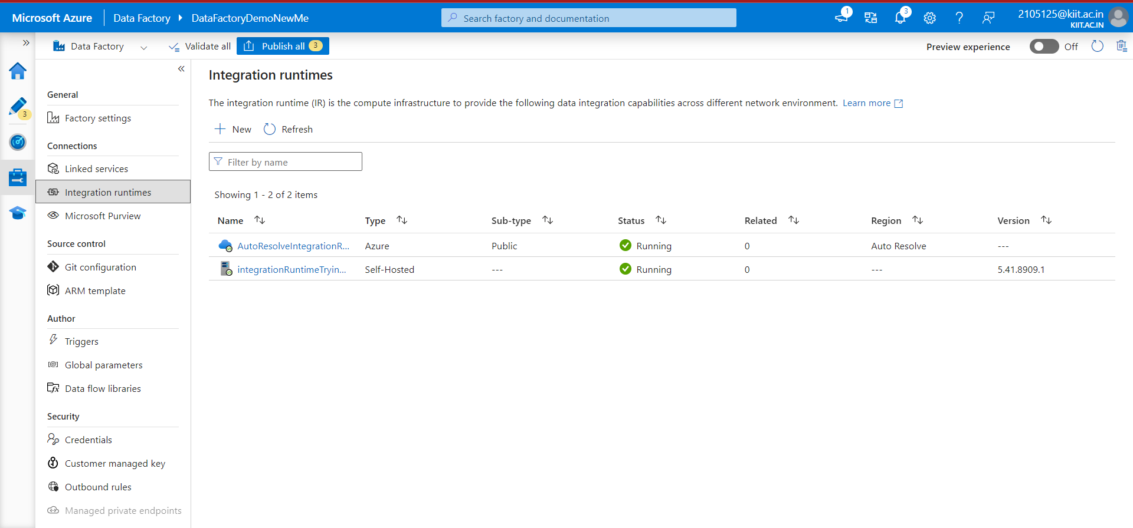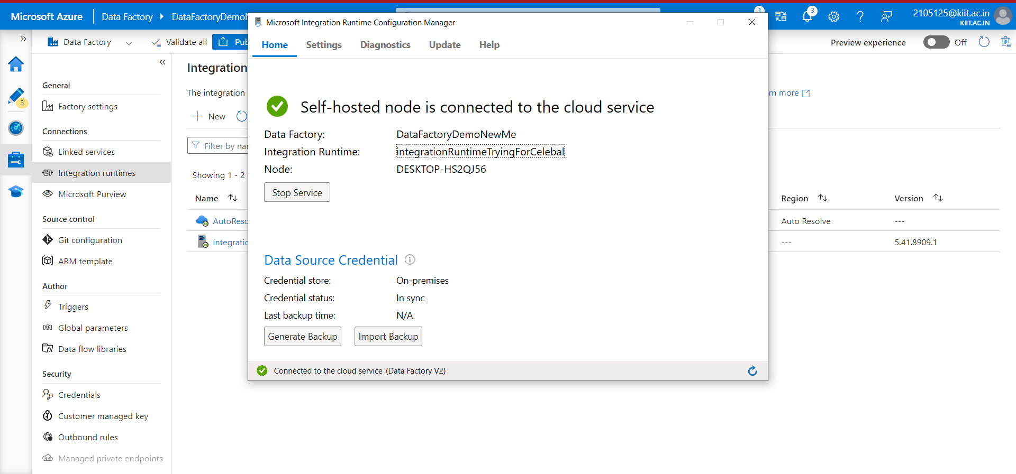

Step 2) Connect your local DB

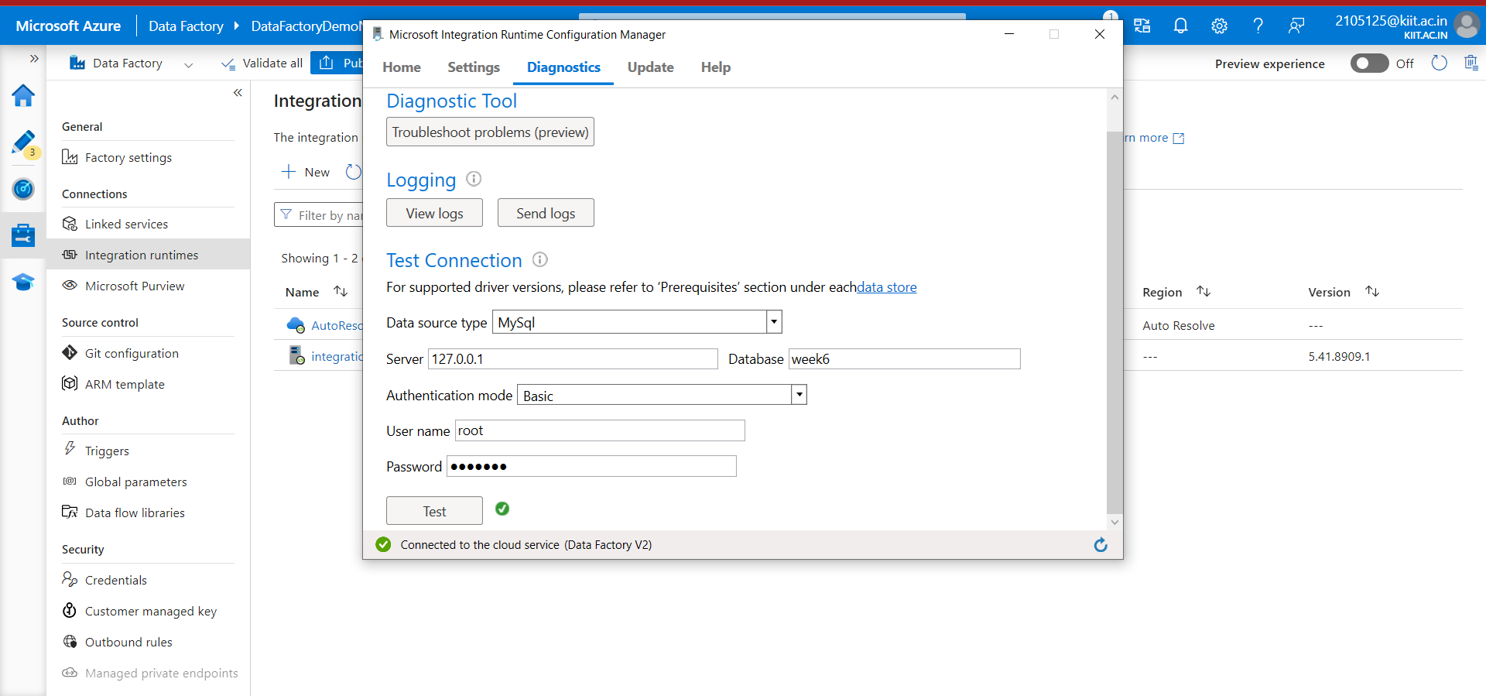

Step 3) Create Linked service from integrated runtime with azure data factory

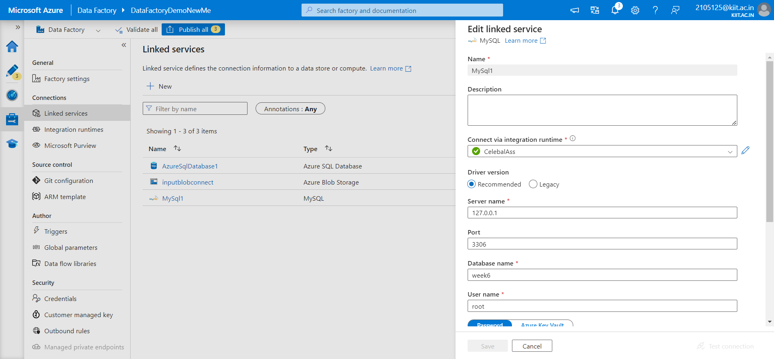

Step 4) Create Databases for both local server and sql server in azure

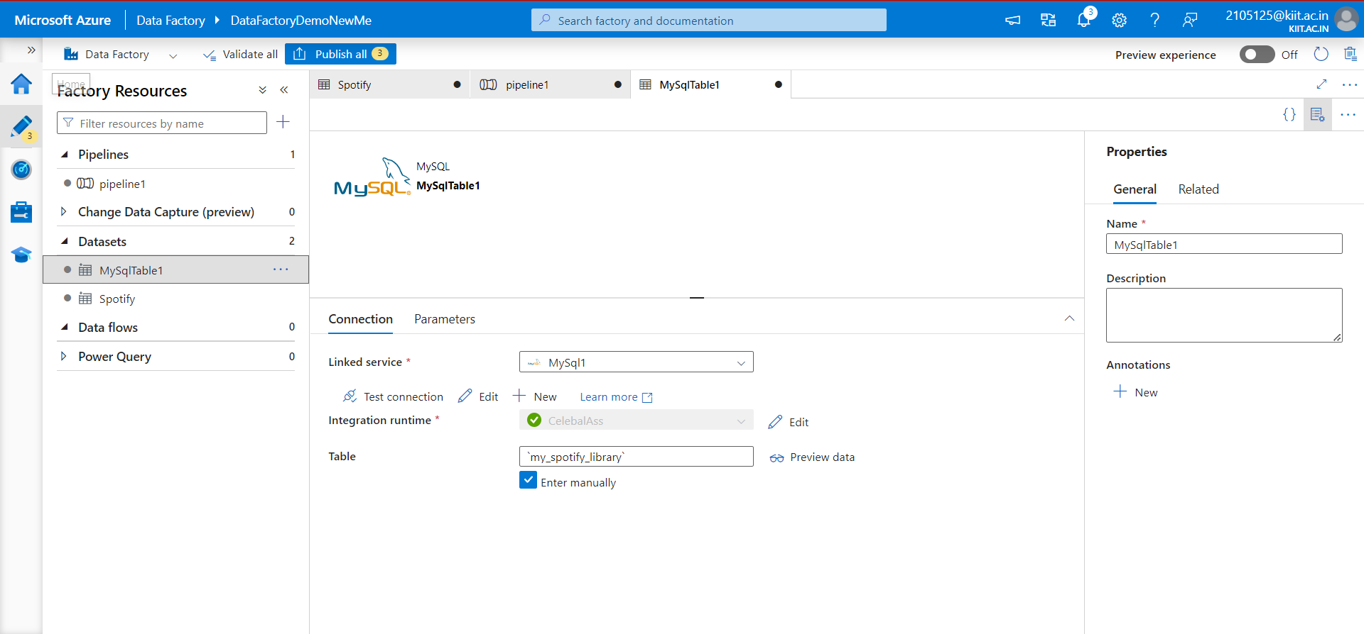

Step 5 )Create a new pipeline in Azure Data Factory.

Add a copy activity to the pipeline.

Configure the copy activity to use the MySQL dataset as the source and the Azure SQL Database dataset as the sink.

Map the columns between the source and destination as needed.

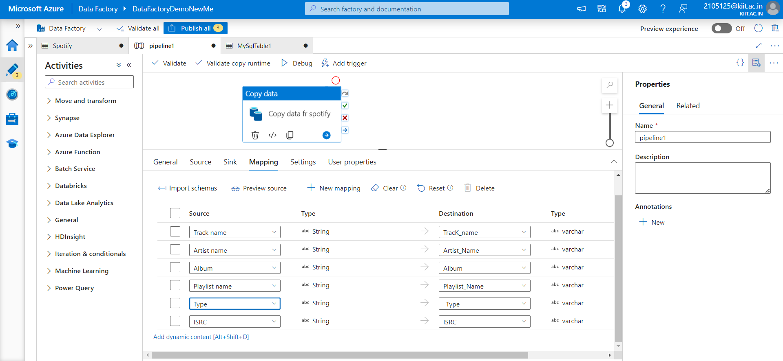

Step 6) Test the pipeline

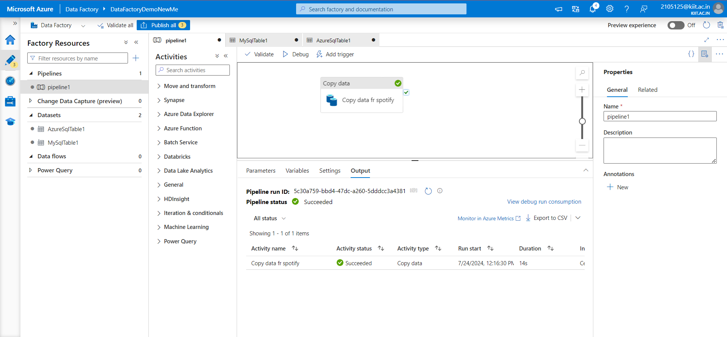

Q3)Create Incremental load pipeline and automate this on daily basis

Step 1) Ingest Data with a Timestamp Column

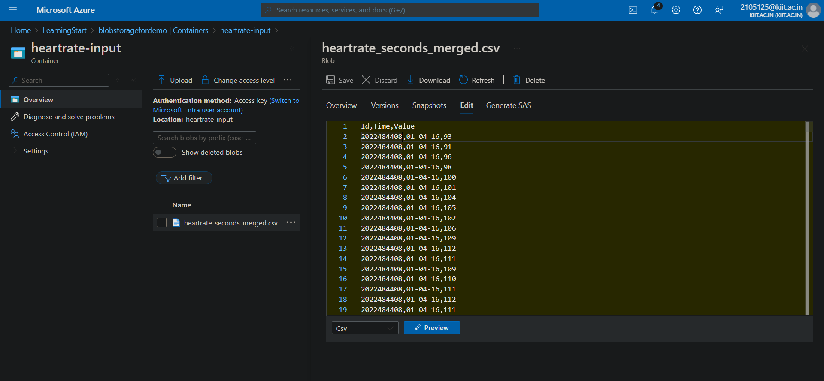

Step 2)Create a new dataset for your source data and sink data

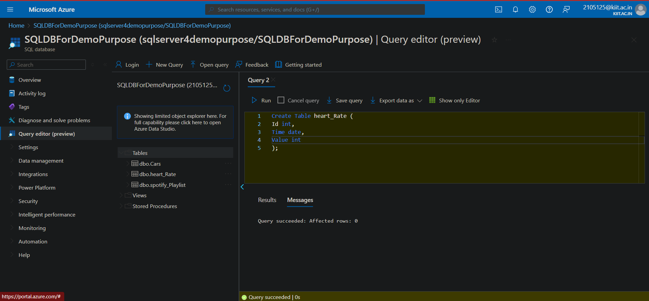

Step 3) Create a Pipeline for Incremental Load with lookup activity and copy activity

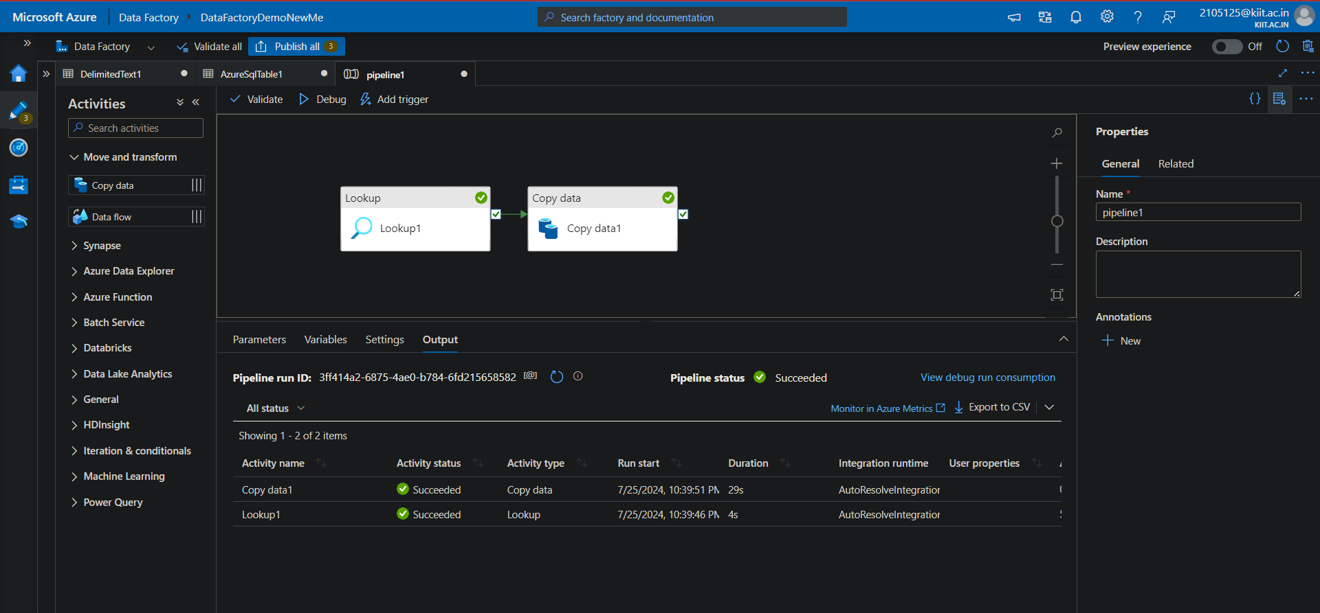

Q4)Automate a pipline to trigger every last Saturday of the month

